Student’s name | …………………………………………………….…… | Grade | 3
Subject | Computer | Week No. | 14
Lesson Title | Conditions | Unit
Worksheet No. ( 14 ) (Answer)

Question A: Write the correct name of each part.

Choose a Sprite | Touching | Key pressed | Touching color
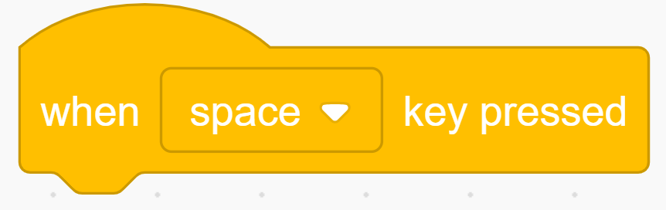



Good Luck

Touching
Choose a Sprite
Touching color
Key pressed

